select e.empno,e.ename,d.dname,d.dloc
from employee e,dept d
where e.deptno=d.deptno;


select e.ename,e.empno
from employee e
where empno not in(select empno from assignedto);


select d.deptno,d.dname,avg(e.sal) as avg_salary,max(e.sal) as max_salary
from dept d, employee e
where e.deptno=d.deptno
group by d.deptno,d.dname;

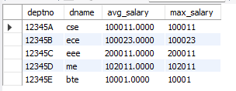
select e.ename,sum(i.iamount) as total_incentives
from employee e,incentives i
where e.empno=i.empno
group by e.ename;

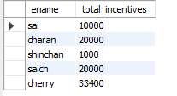
select e.empno,e.ename,p.pname
from employee e,assignedto a,project p
where e.empno=a.empno and p.pno=a.pno and p.pname="proj1";


select d.deptno,d.dname
from dept d
where d.deptno not in (select deptno from employee);


ALTER TABLE employee MODIFY MGR_NO VARCHAR(10);
SELECT e.MGR_NO AS manager_id,m.ename AS manager_name,COUNT(*) AS report_count
FROM employee e, employee m
WHERE e.MGR_NO = m.empno
GROUP BY e.MGR_NO, m.ename;


select empno
from assignedto
where (pno<1)
group by empno;



